**PROJECT-7**

**Histogram Equalization and Specification**

EE5356 Digital Image Processing

Dr. K. R. Rao

Submitted By:

Ashutosh Desai

UTA ID:1001388602

Email: - ashutoshrajesh.desai@mavs.uta.edu

March 6th 2018

EE 5356 - DIGITAL IMAGE PROCESSING - PROJECT 5

Histogram Equalization and Specification

Steps:

1. Read ‘elaine.512.tiff’ image and obtain its histogram.

2. Perform global histogram equalization on the image and obtain its histogram.

3. Perform local histogram equalization on the image and obtain its histogram.

4. Perform direct histogram specification on the image where the desired histogram is a straight line from (0,0) to (1,1).

5. Repeat step 1 to 4 for ‘pout.tif’ image.

Submit the following:

1. Display the image and its histogram obtained in each step.

2. Compare the histogram modification techniques.

3. Give the matlab code.

References:

1. Practical image and video processing using MATLAB by Marques, Oge

**MATLAB CODE:**

clc

close all

clear all

IP_Image = imread('D:\STUDY\DIP\Test img\elaine.512.tiff');

subplot(1,2,1);

imshow(IP_Image);

title('Orignal Image');

% Histogram of Image (Part 1)

subplot(1,2,2);

imhist(IP_Image);

title('Histogram of orignal image');

% Local Histogram Equalization (Part 2)

Lcl_Eq_2 = adapthisteq(IP_Image,'clipLimit',0.02,'Distribution','rayleigh');

figure;

subplot(1,2,1);

imshow(Lcl_Eq_2);

title('Image after Local Histogram equalization');

subplot(1,2,2);

imhist(Lcl_Eq_2);

title('histogram of Local Histtogram Equalization');

% Global Histogram Equalization (Part 3)

Global_Eq = histeq(IP_Image);

figure;

subplot(1,2,1);

imshow(Global_Eq);

title('Image after Global Histogram Equalization');

subplot(1,2,2);

imhist(Global_Eq);

title('histogram of Global Histogram Equalization');

% (Part 4)

ln = linspace(0,1,256);

Histogram = histeq(IP_Image,ln);

figure;

subplot(1,2,1);

imshow(Histogram);

title('Image after Direct Histogram Specification');

subplot(1,2,2);

imhist(Histogram);

title('Histogram');

plot(ln);

title('Desired Histogram Shape'),ylim([0 1]), xlim([1 256])

% For Pout Image

Ip_Image_2 = imread('pout.tif');

figure;

subplot(1,2,1);

imshow(Ip_Image_2);

title('pout.tif');

subplot(1,2,2);

imhist(Ip_Image_2);

title('Histogram of input image(2)');

Lcl_Eq_2 = adapthisteq(Ip_Image_2,'clipLimit',0.02,'Distribution','rayleigh');

figure;

subplot(1,2,1);

imshow(Lcl_Eq_2);

title('Image after Local Histogram Equalization');

subplot(1,2,2);

imhist(Lcl_Eq_2);

title('Histogram of Local Histogram Equalization');

Global_Equalization2 = histeq(Ip_Image_2);

figure;

subplot(1,2,1);

imshow(Global_Equalization2);

title('Image after Global Histogram Equalization');

subplot(1,2,2);

imhist(Global_Equalization2);

title('Histogram of Global Histogram Equalization');

ln=linspace(0,1,256);

Histogram2 = histeq(Ip_Image_2,ln);

figure;

subplot(1,2,1);

imshow(Histogram2);

title('image(2) after direct Histogram specification');

subplot(1,2,2);

imhist(Histogram2);

title('Corresponding histogram')

plot(ln), title('Desired Histogram Shape'),ylim([0 1]), xlim([1 256])

**OUTPUT;**

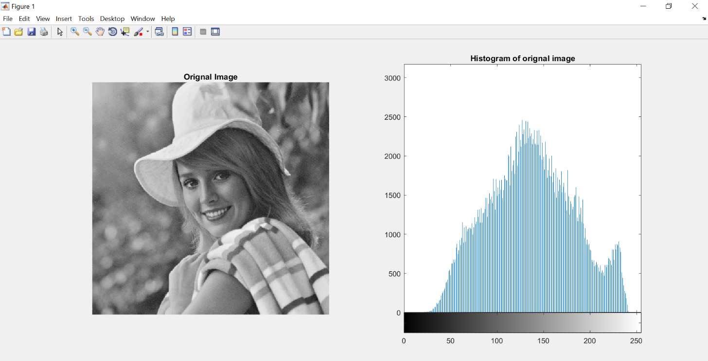

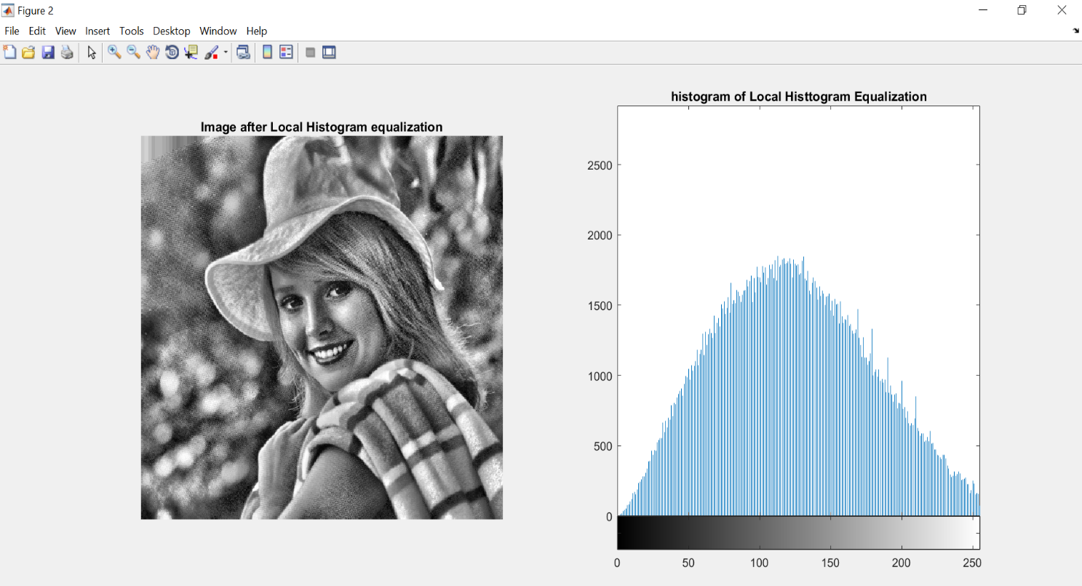

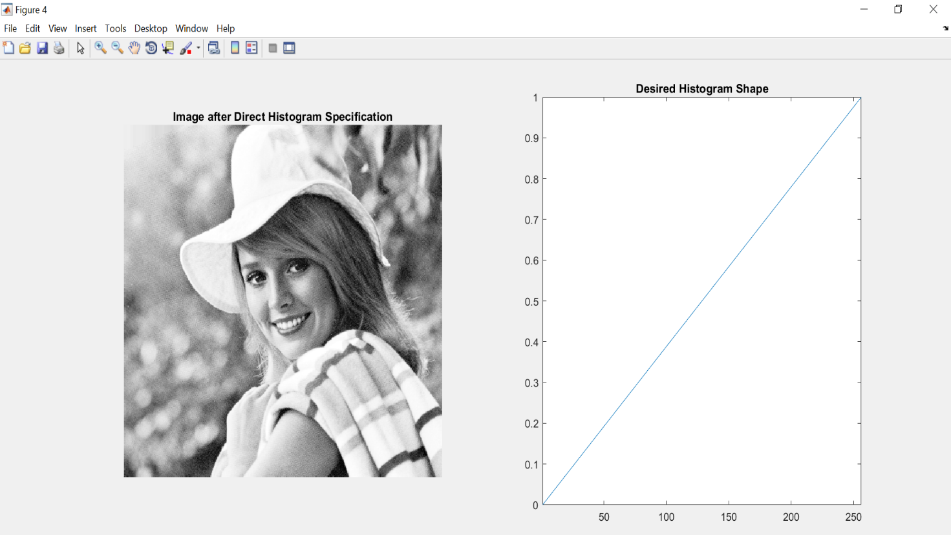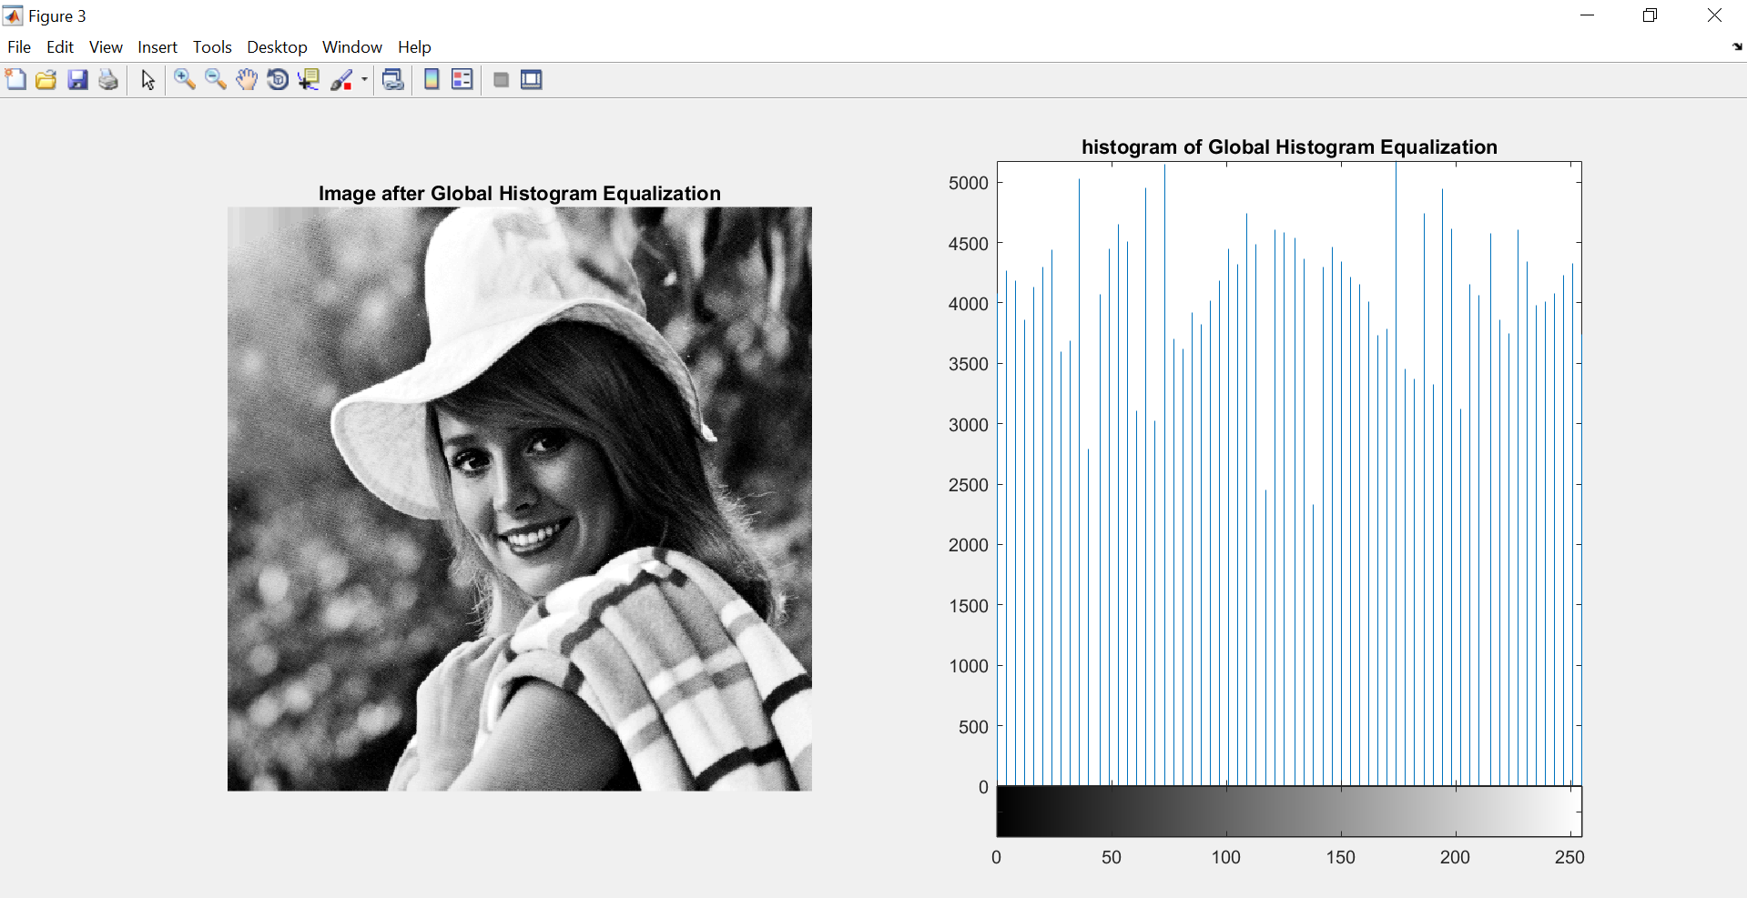

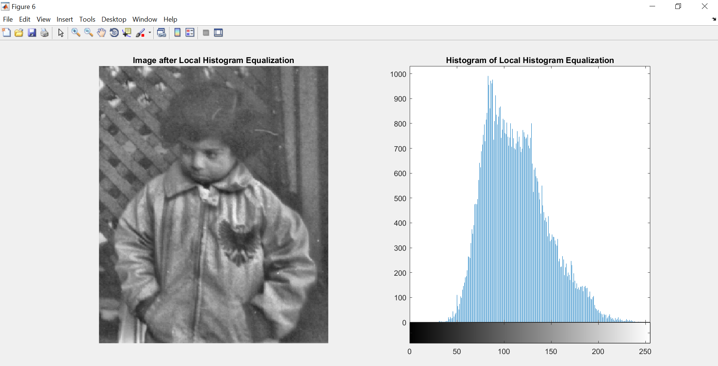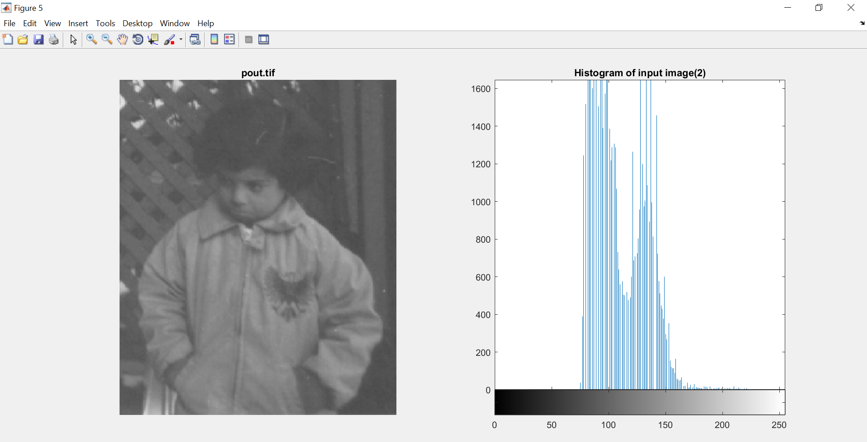

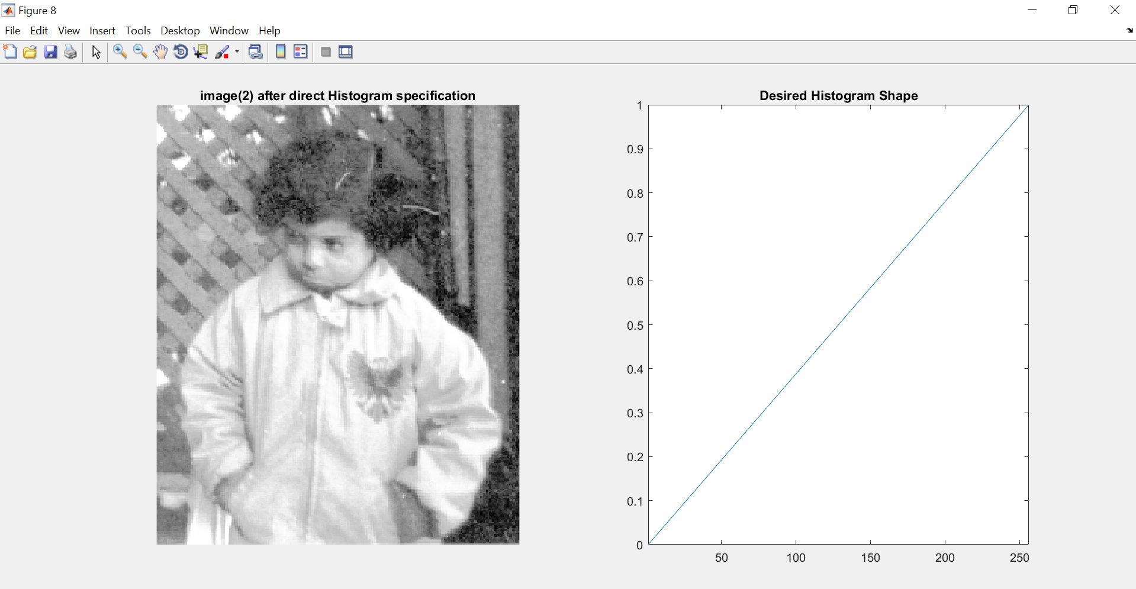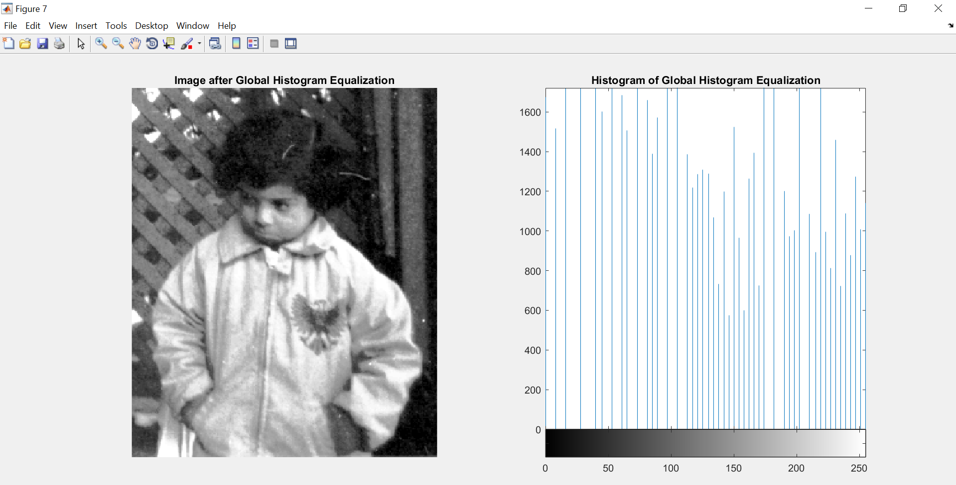

**EXPLAINATION:**

* Global histogram equalization usually increases the global contrast of many images, especially when the usable data of the image is represented by close contrast values.
* Local histogram equalization or Adaptive histogram equalization (AHE) is a computer image processing technique used to improve contrast in images.
* The histogram equalization method is quite useful but it is not suitable for interactive image enhancement applications because the capabilities of this method are limited to the generation of only one result i.e. an approximation to a uniform histogram.

**CONCLUSION:**

In this project we performed the histogram of the images. The histogram plot shows the quantity of the pixel value getting repeated in the given image. In Local Histogram Equalization we did the gray scale image transformation using Contrast limited Adaptive Histogram Equalization and in Global Histogram Equalization, we enhanced the images using histogram equalization.